Supplemental Information for

Multiresonant Membrane Metasurfaces for Multifunctional Molecular Absorption Sensing and Real-time Biochemical Tracking

Quanlong Yang^{1,*}, Yapeng Dou², Dongyang Wang³, Yihua Zhong¹, Fei Li⁴, Jiajun He⁵, Ying Zhang^{4,*}, Quan Xu⁵, Junliang Yang¹, Ilya Shadrivov⁶, Jiaguang Han⁵, and Yuri Kivshar^{6,*}

1 Key Laboratory of Micro-Nano Fabrication and Device Manufacturing in Universities of Hunan Province, School of Physics, Central South University, Changsha 410083, China
2School of Electronic Information, Central South University, Changsha 410083, China
3Optoelectronics Research Centre, University of Southampton, Southampton SO17 1BJ, UK
4Yunnan Key Laboratory of Opto-electronic Information Technology and Institute of Physics and Electronic Information, Yunnan Normal University, Kunming 650500, China
5Center for Terahertz Waves, Tianjin University, Tianjin 300072, China
6Research School of Physics, Australian National University, Canberra ACT 2601, Australia
*Corresponding author. Email: quanlong.yang@csu.edu.cn; yingzhang27@ynnu.edu.cn; yuri.kivshar@anu.edu.au

Fig. S1. Band dispersion of DHR metasurface.
Fig. S2. Supplementary measured transmission spectra and fitted results.
Fig. S3. Electric field enhancement of DHR
Fig. S4. Multipole evolution of DHR under different orientation angles.
Fig. S5. Fingerprint spectra of metasurface under different orientation angles.
Fig. S6 Control experiment of the metasurface with φ = 30° using lactose and vitamin C.
Fig. S7. Dynamic monitoring spectral changes of vitamin C for the remaining four configurations.
Fig. S8. Metasurface morphologies during dynamic oxidation monitoring of vitamin C.
Fig. S9. THz transmission spectra of Vitamin C oxidation on COC substrate.
Tab.S1. Kinetic parameters of THz metasensors under varied conditions.

Supplementary Note 1: Band dispersion of DHR metasurface

We calculated the band dispersion and frequency characteristics of the DHR metasurface using Eigenmode analysis in COMSOL, as illustrated in Supplementary Figure 1. In Fig. S1a, with an orientation angle of φ = 0°, two target resonances (marked by the blue triangles) occur at the Γ point at 0.78 and 0.99 THz. While for the φ = 10°, two BIC modes display a negligible frequency shift compared to φ = 0°. To explore the band dispersion of the DHR metasurface versus the orientation angle, the frequency evolution of DHR at the Γ point is displayed in Fig. S1c. Both BIC I and BIC II, represented by the red solid dots, maintain stable frequencies of 0.78 and 0.99 THz, respectively, which are in good agreement with both the simulated and measured results shown in Fig. 2b.

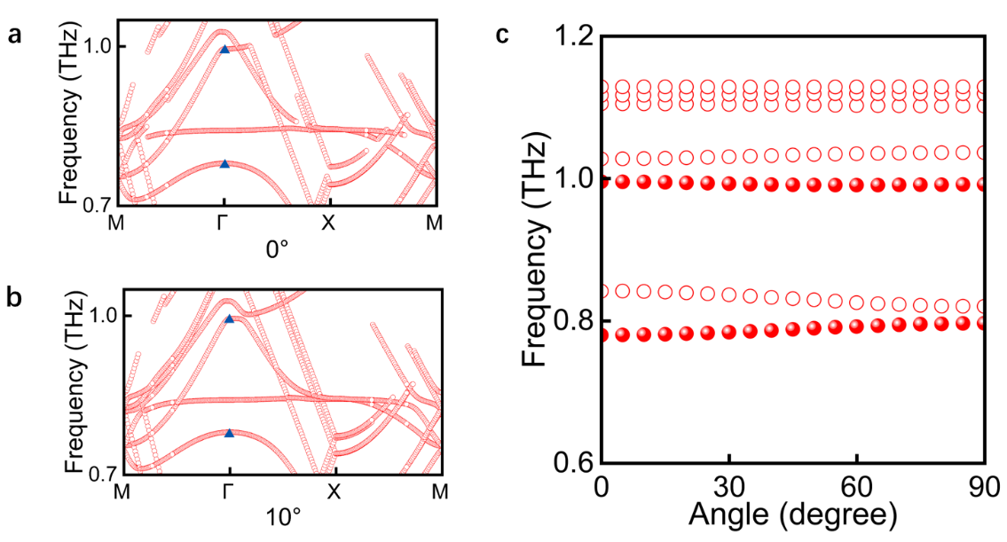
Supplementary Figure 1. Band dispersion of DHR metasurface. (a) Band dispersion of the metasurface with an orientation angle of φ = 0°. (b) Band dispersion with an orientation angle of φ = 10°. (c) Frequency evolution at the Γ point versus the orientation angle, derived from band dispersion analysis.

Supplementary Note 2: Supplementary Characterizations of multiple resonances

Supplementary Figure 2a displays the supplementary experimental transmission spectra with the orientation angle ranging from 0° to 90°. BIC I exhibits a slight frequency shift at smaller orientation angles, while a slight red shift occurs at BIC II. We further employed the temporal coupled mode theory to analyze the coupling behavior of multiple resonances. The transmission of the coupled systems could be described as follows:
$$T=t_{0}\frac{\left(ω_{1}-ω+iγ_{i1}\right)\left(ω_{2}-ω+iγ_{i2}\right)-β^{2}}{\left(ω_{1}-ω+iγ_{i1}+iγ_{e1}\right)\left(ω_{2}-ω+iγ_{i2}+iγ_{e2}\right)+\left(p\sqrt{iγ_{e1}iγ_{e2}}-iβ^{2}\right)}$$
Here, ω₁, γ_{i1} and γ_{e1} ( ω₂, γ_{i2} and γ_{e2}) are the frequency, intrinsic loss and radiative loss of the modes, respectively. p denotes the phase difference and β represents the coupling parameters between the two modes. The fitted spectra in Fig. S2b match well with the calculated results, with peak position deviation ≤ 0.01 THz, and accurately reproduce the peak linewidths and intensity distributions.
Moreover, we calculated the electric field distribution of multiple resonances, which is shown in Fig. S3. Both BIC I and II exhibit significant variation in electric field enhancement as the orientation angle changes. These results are consistent with the evolution of resonant characteristics in the transmission spectrum, including the angular dependence of peak positions and linewidths. This provides direct evidence for the governing rules of symmetry breaking on mode distribution and coupling behavior.

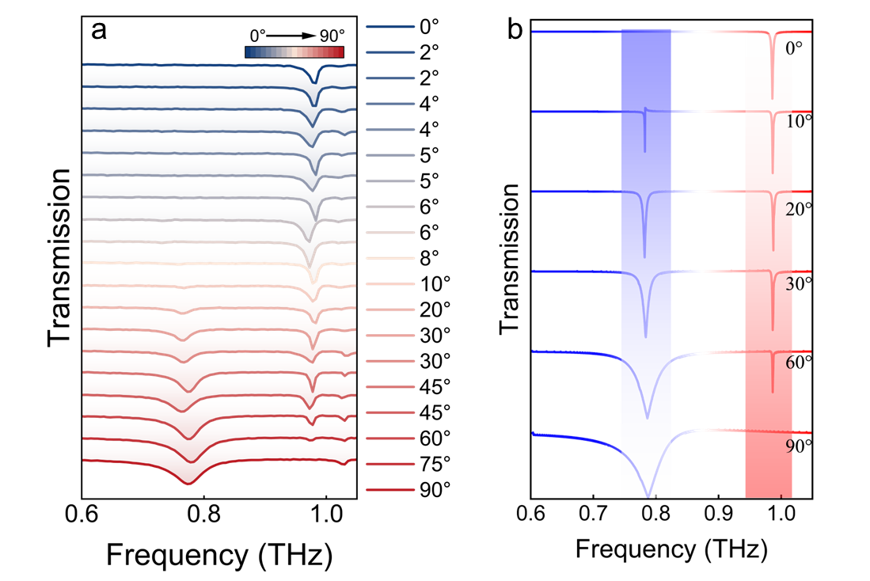
Supplementary Figure 2. Supplementary measured transmission spectra and fitted results. (a) Experimentally measured transmission spectra; (b) Fitted transmission spectra from the coupled mode theory (CMT).

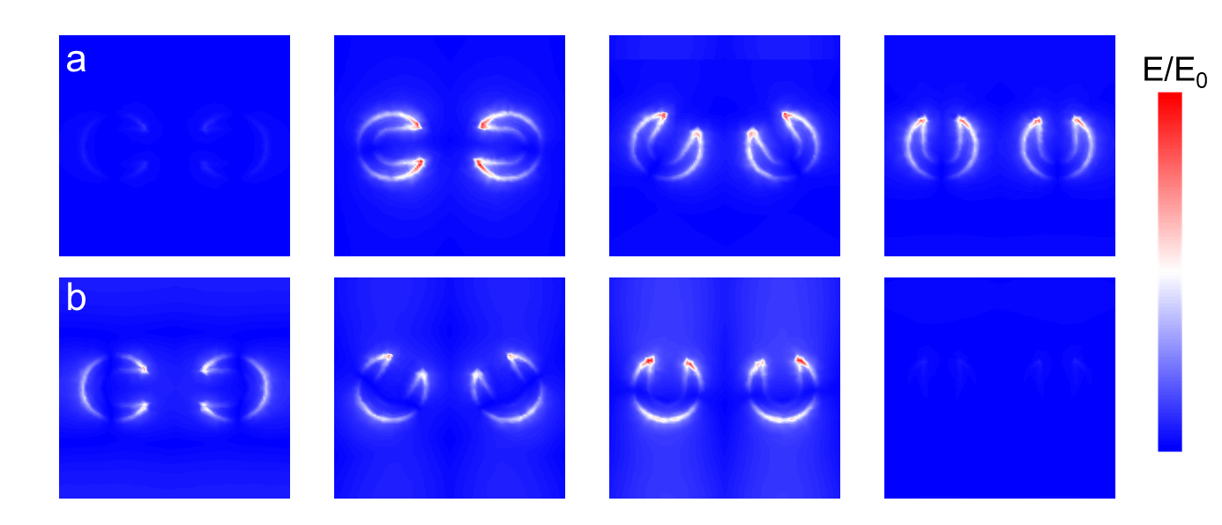
Supplementary Figure 3. Electric field enhancement of DHR. (a) Electric field enhancement of BIC I at the orientation angle of φ = 0°, 5°, 60°, and 90°. (b) Electric field enhancement BIC2 at the orientation angle of φ = 0°, 60°, 85°, and 90°.

Supplementary Note 3: Multipole decomposition analysis of DHR metasurface

We further performed the multipole decomposition analysis of the DHR metasurface at different orientation angles. At smaller orientation angles, the performance of BIC I is primarily governed by magnetic dipole (MD), while BIC II is dominated by electric dipole (ED). As the orientation angle increases, the contribution of ED to BIC I becomes more prominent, while the contribution of MD to BIC II increases. When the angle approaches 90°, the roles of ED and MD at BIC I and BIC II undergo a complete inversion, which is consistent with both the simulated and measured transmission spectra of the DHR metasurface.

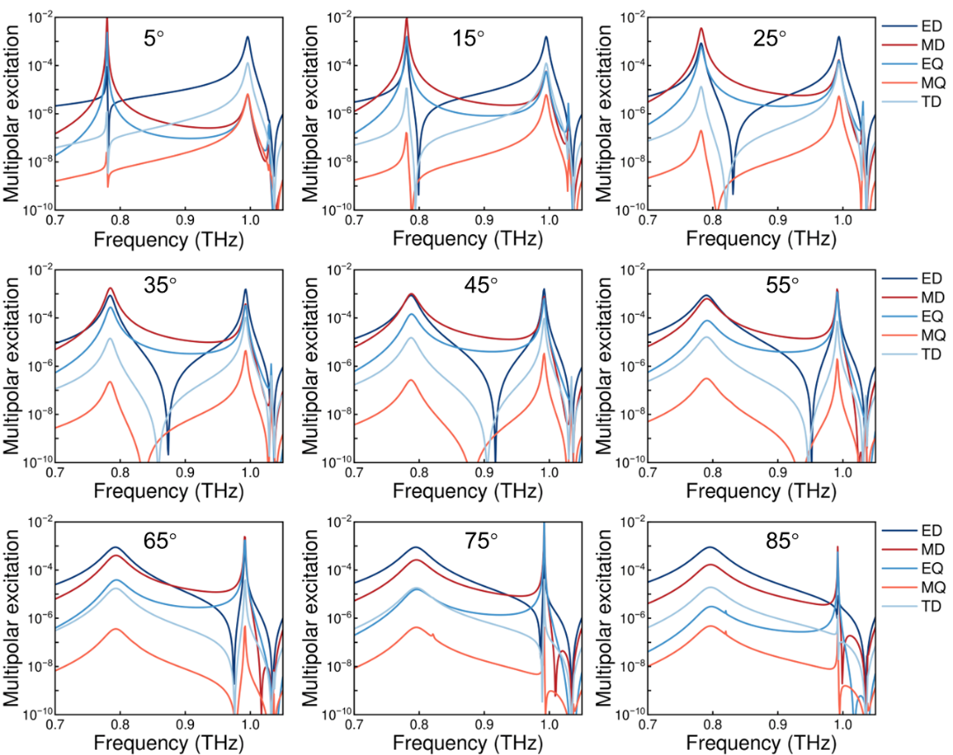
Supplementary Figure 4. Multipole evolution of DHR under different orientation angles.

Supplementary Note 4: Fingerprint sensing with pefloxacin

The alignment of multiple resonances and fingerprint absorption features of PEF is a deliberate design strategy termed resonance matching, which is essential for boosting the light-matter interaction. Since the intrinsic absorption of PEF molecules is extremely weak, especially at low concentrations, we specifically engineered the metasurface to exhibit high-Q resonances at 0.78 and 0.99 THz. This alignment creates intense localized electric field enhancement (hotspots) at the exact frequencies of the PEF fingerprints, effectively acting as a signal amplifier that increases the absorption cross-section of the analyte. This design allows selective enhancement of molecular fingerprints, enabling accurate identification even at trace concentrations.
In Fig. S5a–S5d, the transmission spectra of pefloxacin on four DHR metasurfaces (at 0°, 30°, 60°, and 90°) are measured for five different concentrations of PEF (1.67 ng/μl, 16.78 ng/μl, 0.17 μg/μl, 0.84 μg/μl, and 3.36 μg/μl). The variations in amplitude and full width at half maximum (FWHM) with different concentrations provide direct evidence of the correlation between PEF concentration and absorption peak. As a comparison, the absorption spectrum of the COC layer (without metasurface) with PEF is also measured in the same way, which is shown in Fig. S5e–S5h. Interestingly, there are no absorption peaks that could be identified from the spectrum without metasurface. For metasurfaces with different orientation angles, two absorption peaks are observed in all samples, with the amplitude of the absorption peaks showing a direct correlation with the Q factors.

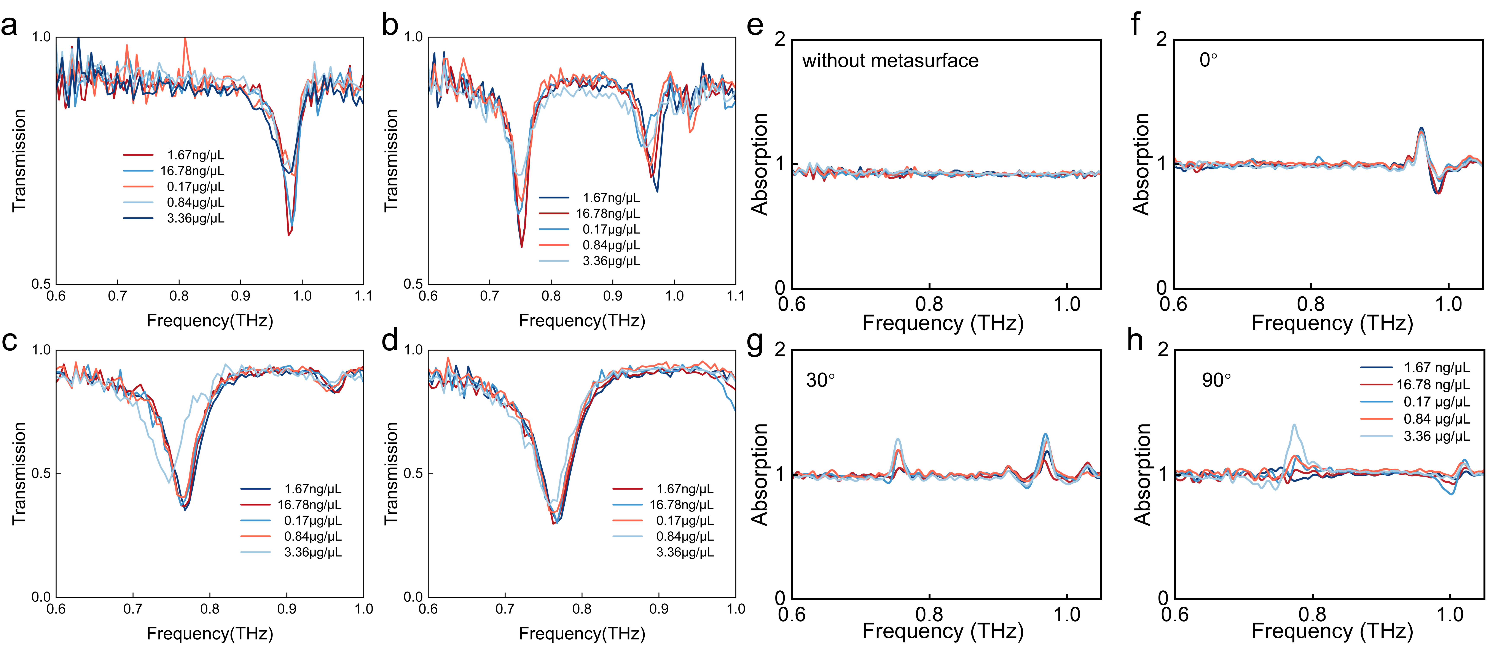
Supplementary Figure 5. Fingerprint spectra of metasurface under different orientation angles and pefloxacin concentrations. (a-d) Measured transmission spectra of metasurface with the orientation angle of 0°, 30°, 60°, and 90°. Here, five different concentrations are employed to explore the performance of the metasurface. (e-h) Calculated fingerprint spectra with and without metasurface. Here, three metasurfaces with the orientation angle of 0°, 30° and 90° are adopted.

Supplementary Note 5: Control experiment using lactose and vitamin C
To further distinguish the molecular absorption-induced response from general resonance perturbations caused by analyte loading, control experiments were performed using lactose and vitamin C under identical conditions. The normalized transmission spectra measured on metasurfaces with φ = 30° and φ = 60° are shown in Figure S2. Both analytes introduce resonance perturbations, resulting in derivative-like spectral features after normalization, consistent with the simulated response induced by refractive-index variations. However, no frequency-selective absorption feature comparable to the pefloxacin response is observed around the second resonance. The measured spectral response is governed by the spectral overlap between molecular absorption and the engineered resonances, rather than by analyte-induced resonance perturbations alone.
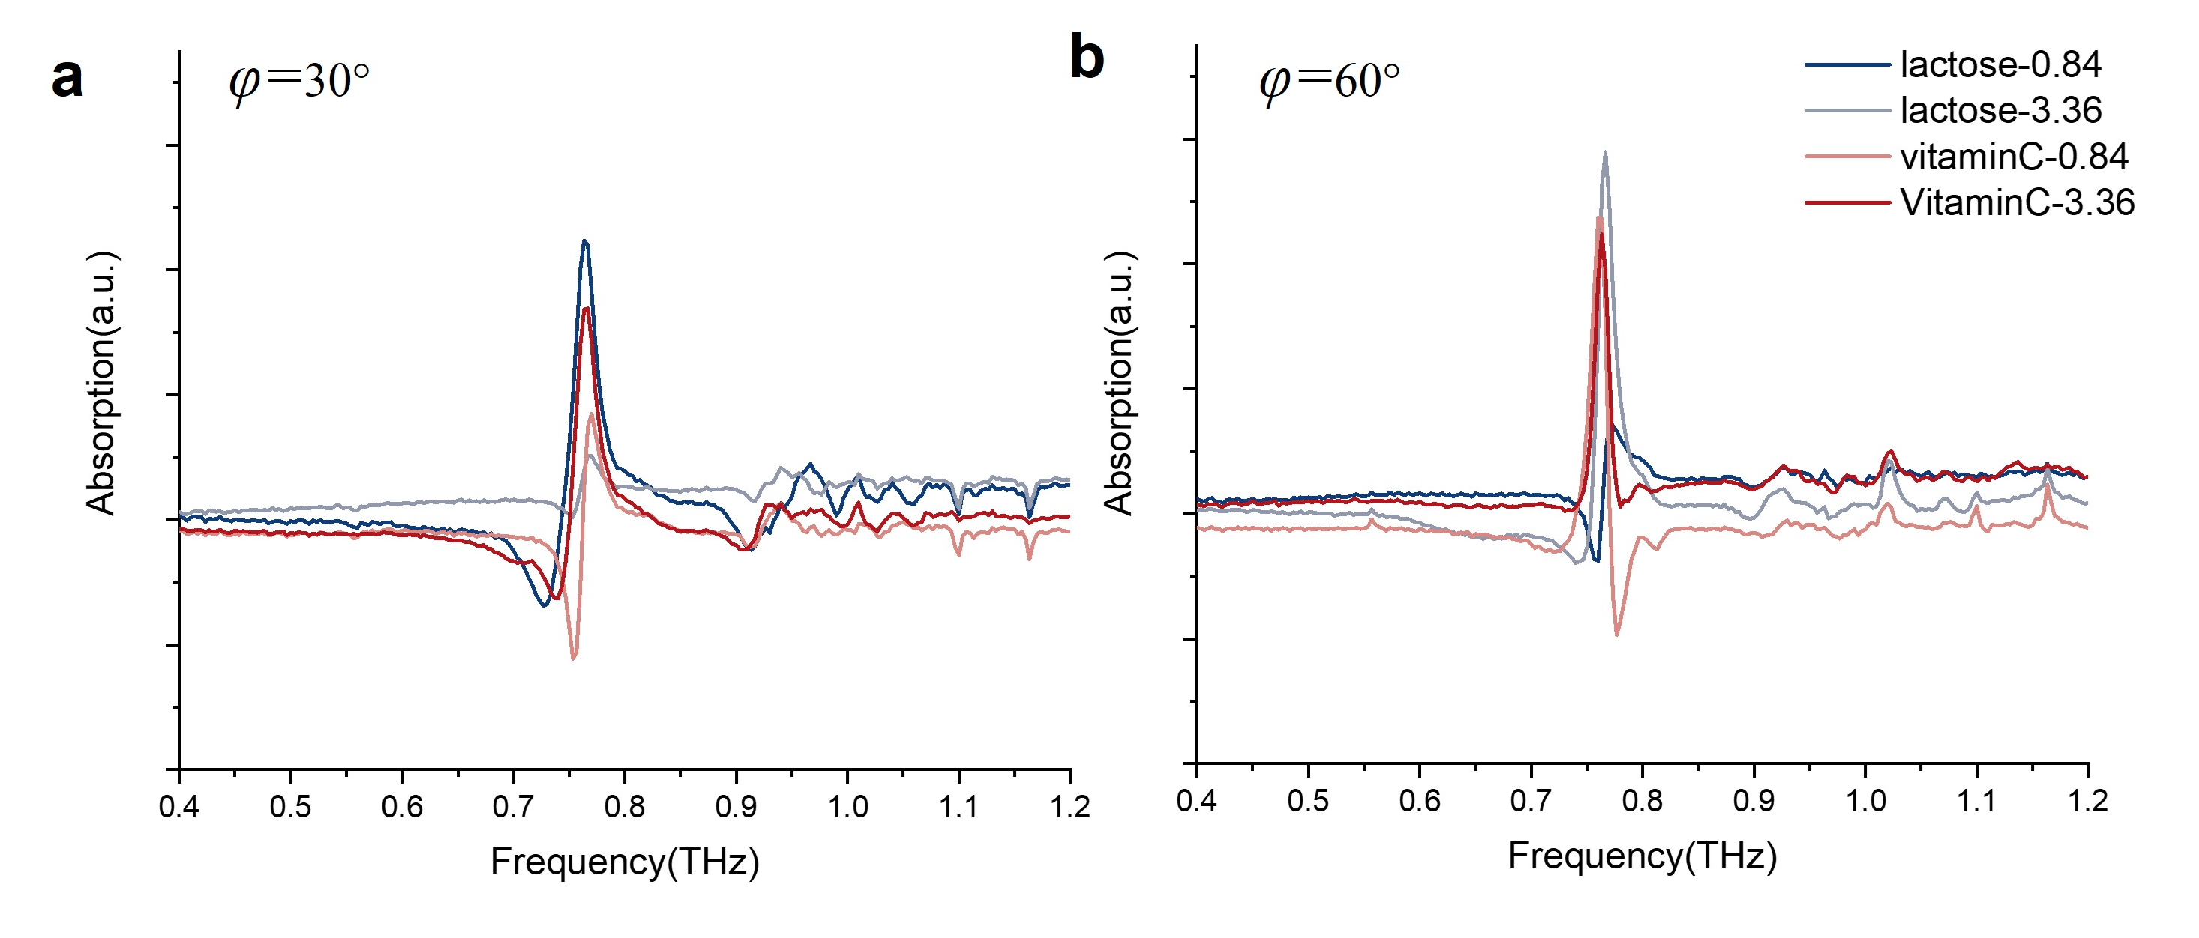
Supplementary Figure 6. Control experiment of the metasurface with φ = 30° using lactose and vitamin C. (a) Control experiment of the metasurface with φ = 30° using lactose and vitamin C. (b) Control experiment of the metasurface with φ = 60° using lactose and vitamin C.

Supplementary Note 6: Dynamic Monitoring of Vitamin C Oxidation with DHR metasurface

Also, we measured the transmission spectrum evolution during vitamin C oxidation on the metasurface over 0–60 minutes, covering four orientation angle-concentration configurations (90°-10 μg/μL, 90°-40 μg/μL, 60°-25 μg/μL, 60°-40 μg/μL). There are three spectrum results can be seen in Fig. S7, the reference spectrum (marked by "Original"), the post-cleaning spectrum ("Restored") and time-dependent transmission spectra over the 0 to 60-minute vitamin C oxidation period for each configuration. All the original and restored spectra match well, indicating that the metasurface is not affected by the oxidation of vitamin C. All the spectral characteristic peak positions remain largely unchanged, while the transmission amplitude of vitamin C oxidation decreases with the oxidation time increase. This shows good agreement with the conclusion in Figure 5. These dynamic differences directly correlate with the electromagnetic interaction strength between the metasurface and vitamin C oxidation products. During oxidation, vitamin C undergoes molecular structural changes. Specifically, hydroxyl group oxidation to carbonyl groups, which induces variations in its dielectric properties.

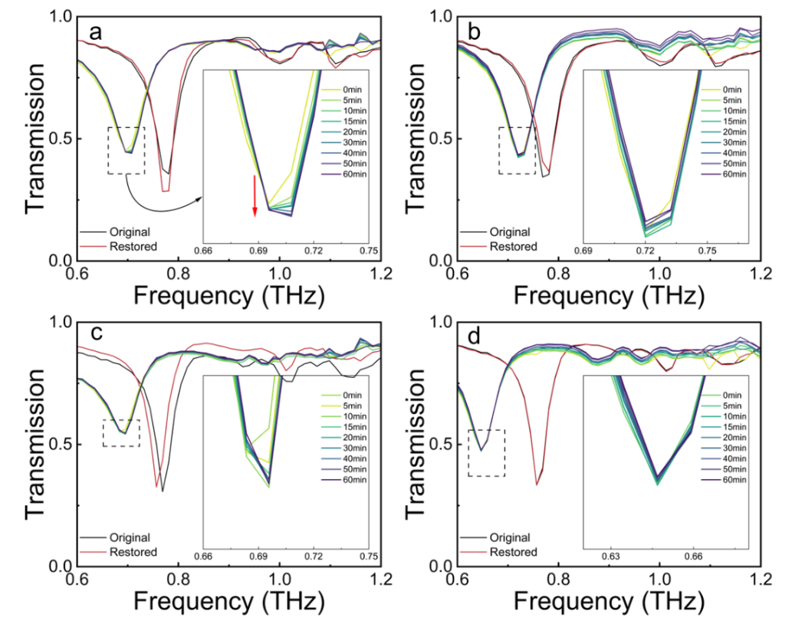
Supplementary Figure 7. Dynamic monitoring of spectral changes of vitamin C for the remaining four configurations. (a) Measured transmission performance of metasurface with φ = 90° and concentration of vitamin C is 10 μg/μL. (b) Measured transmission performance of metasurface with φ = 90° and concentration of vitamin C is 40 μg/μL. (c) Measured transmission performance of metasurface with φ = 60° and concentration of vitamin C is 25 μg/μL. (b) Measured transmission performance of metasurface with φ = 60° and concentration of vitamin C is 40 μg/μL.

Supplementary Note 7: Morphological variations of DHR metasurface under distinct states

Supplementary Figure 8 illustrates morphological variations of the DHR metasurface under distinct states during dynamic vitamin C oxidation monitoring. In the absence of vitamin C, the metasurface maintains its initial intact structure, following vitamin C exposure, traces of interaction with vitamin C molecules are observable on the metasurface. After cleaning, the metasurface morphology is largely restored to its initial state. These morphological changes directly reflect the dynamic response and recovery trends observed in the transmission spectra, confirming the structural restoration of the metasurface after cleaning. This provides clear morphological evidence supporting the metasurface’s reusability for dynamic oxidation monitoring of vitamin C.

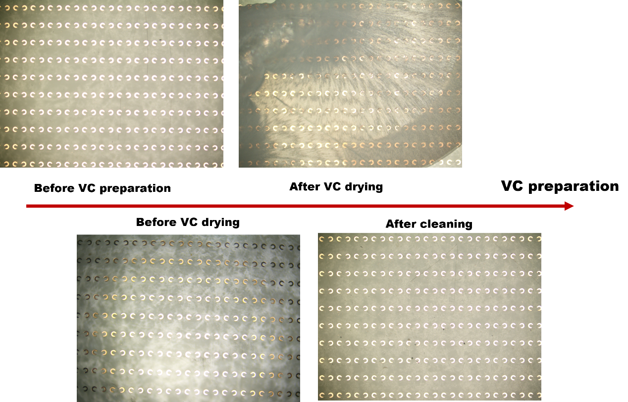
Supplementary Figure 8. Metasurface morphologies during dynamic oxidation monitoring of vitamin C.

Supplementary Note 8: Kinetic Modeling of Vitamin C Oxidation via Michaelis-Menten Framework

The real-time tracking of vitamin C (VC) oxidation on the multiresonant metasurface is quantified using the Michaelis-Menten kinetic model. This framework is adopted based on the functional analogy between the metasurface unit cells and biological enzymatic systems. The electromagnetic field-enhancement hotspots of metasurfaces can exhibit enzyme-like activity (e.g., GOD-like mimetic activity) by capturing, adsorbing, and facilitating the chemical transformation of analyte molecules. In our system, these hotspots function as "virtual enzymes" that mediate the reaction between VC and ambient oxygen. The progression of the oxidation is monitored via the normalized amplitude change rate (Δa/a₀), and the kinetic behavior is described by the following equation:
$$\frac{Δa}{a_{0}}=\frac{V_{max}⋅t}{K_{m}+t}$$
where V_{max} represents the maximum reaction rate (the theoretical limit of amplitude change) and K_{m} is the Michaelis constant, representing the time required to reach half of the maximum amplitude variation.
The validity of applying this model to our sensing platform rests on two critical conditions. First, the oxygen concentration in the ambient environment remains significantly higher than that of the deposited VC molecules throughout the experiment. This satisfies the quasi-steady-state approximation originally established by Briggs and Haldane, which is a prerequisite for Michaelis-Menten kinetics. Second, the experimental data across various concentrations and metasurface configurations show excellent agreement with the nonlinear fitting, as evidenced by the high coefficients of determination (R² > 0.92) summarized in Supplementary Table 1. These results confirm that the metasurface hotspots effectively function as catalytic centers, allowing for the precise extraction of kinetic parameters and the quantitative estimation of initial analyte concentrations. Furthermore, we performed the experiment of oxidative kinetics without a metasurface, the measured transmission performance of VC oxidation on an unpatterned COC substrate is displayed in Supplementary Figure 8. Here, the oxidation of pure VC on a plain COC film results in no characteristic spectral changes or specific resonant features. The maximum amplitude variation over 60 minutes is approximately 0.02, which is indistinguishable from the system’s baseline noise.

Supplementary Table 1. Kinetic parameters of metasensors under varied conditions

Model: Michaelis-Menten | Vmax | Km | Reduced Chi-Square | R-squared (COD) | Adjusted R-squared
90°-10μg/μL | 0.08998 ± 0.0033 | 6.39618 ± 1.01684 | 1.27558×10⁻⁵ | 0.9837 | 0.98137
90°-25μg/μL | 0.07555 ± 0.00395 | 9.07166 ±  1.72721 | 1.28095×10⁻⁵ | 0.97644 | 0.97308
60°-10μg/μL | 0.06799 ± 0.0015 | 1.43779 ±  0.34663 | 5.97638×10⁻⁶ | 0.98862 | 0.98699
60°-25μg/μL | 0.03675 ± 0.00226 | 2.27147 ±  1.10711 | 1.16266×10⁻⁵ | 0.92662 | 0.91613

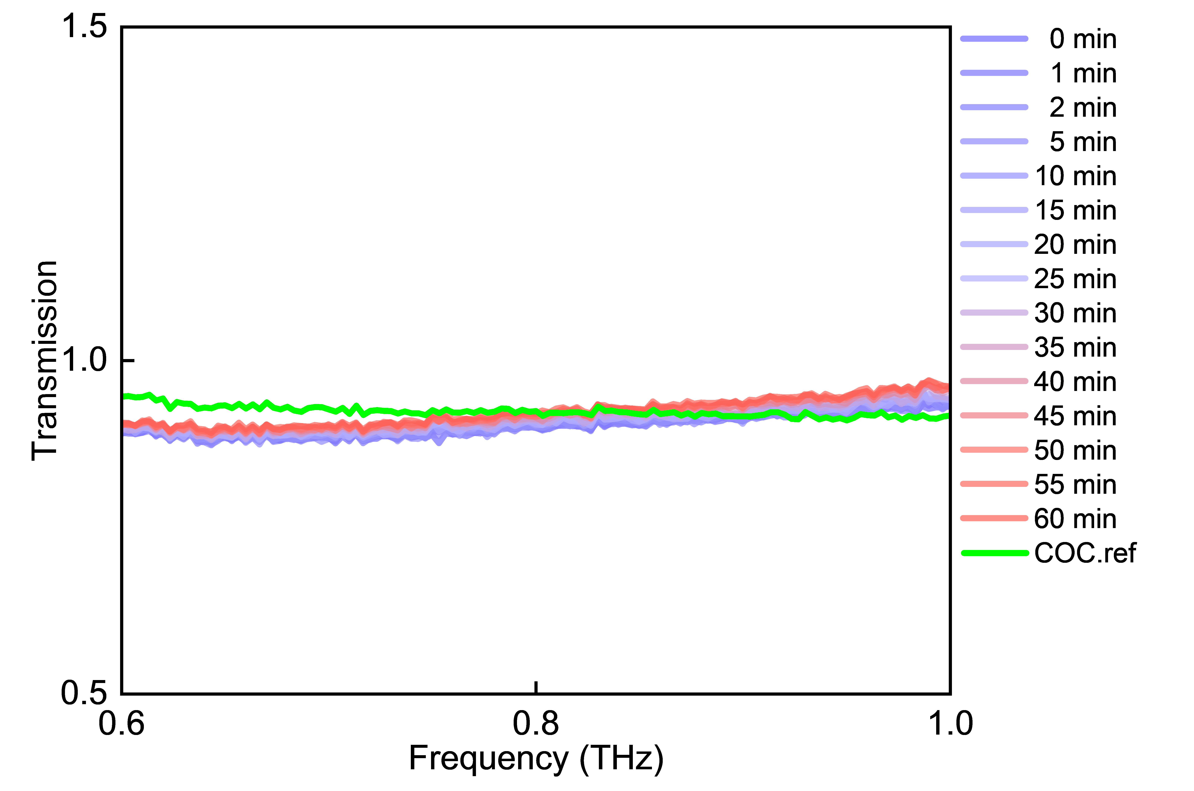
Supplementary Figure 9. THz reference transmission spectra of Vitamin C oxidation on an unpatterned COC substrate.

